**GUEST DETAILS USER GUIDE**

**Technologies**

* We have used EXTJS framework for designing.
* KOHANA framework for backend logic.
* ORM (Object Relational Model) for SQL queries.

Here we have developed a Site where we can enter Guest Details and store those details in Database.

**Features**

1. Add, Edit and Delete a Guest.
2. We can view all Guests in List View (Grid).
3. We can Export Guest Details to excel file.
4. We can Import Guest Details from excel file.
5. We can Print Guest Details.

**Code Explanation**

1. **View**

* GuestListView: This file contains the code for display all Guests in list View. We have code for filtering data, pagination and Toolbar where we have buttons for Export, Import and Print.

Please find below application screen shot.

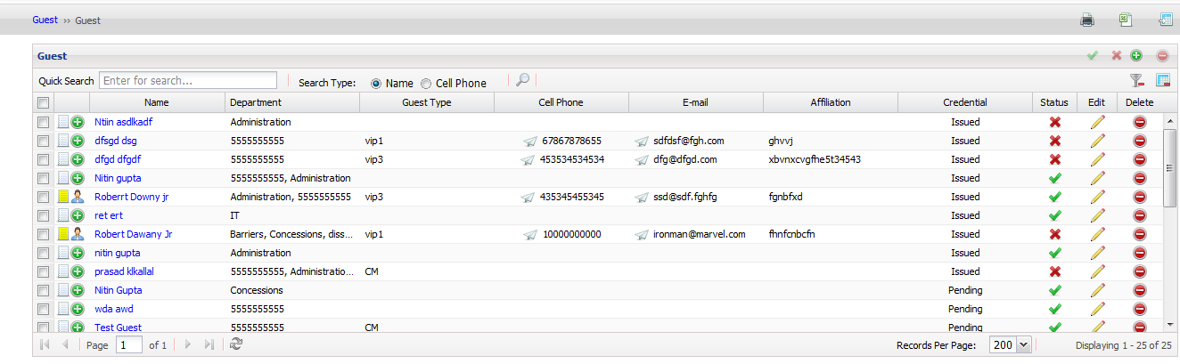

* AddGuestForm: This file contains a view for adding a Guest. Please find below screen of Add Guest detail form and Edit Guest detail form.

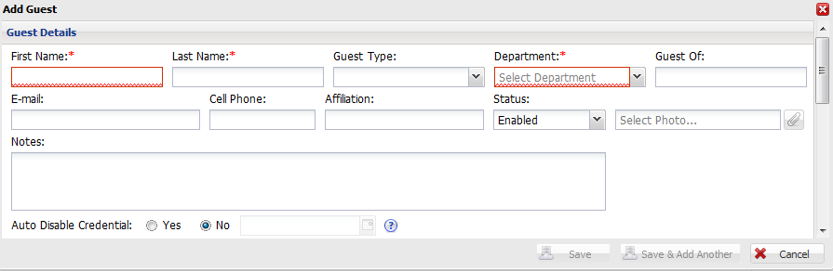

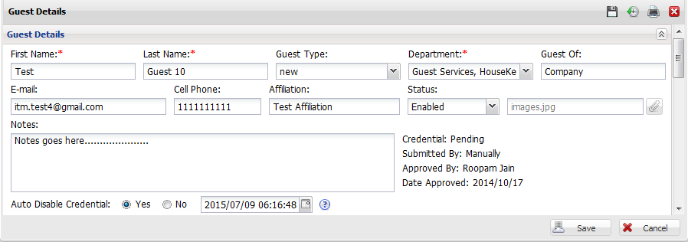

* PrintGuestListView: This file contains a view for printing a Guest list view. Here we are using window.print() registered function of JavaScript for printing the data.

1. **Controller**

* GuestIndex: This file contains all the logical actions and functions.

Actions in the file –

* action_index – This action will be called for loading Guest View. We send Pagination and Grid configuration parameters here.
* action_load_add_guest_form – This action will be called when we click on Add icon in Guest list view
* action_load_guest_details_form - This action will be called when we click on Edit icon in Guest list view
* action_download_sample_excel_file - This action will be called when user wants to download sample import excel file.
* action_import_status_window – This action is used for error logs and status when a record is imported.
* action_import_guest_from_excel – This action contains the logic and validation for importing the records from excel.
* action_load_data_for_guest_list – This action is used to load data in the Guest list View. JSON format is used for storing the data.
* action_delete_guests – This action have the logic for delete single or multiple records. This action will be called when we click delete icon in grid list view.
* action_print_view – This action will be called when we click on print icon on toolbar of GuestlistView.
* action_export_to_excel – This action will be called when we click on Export to excel icon on toolbar of GuestlistView.
* action_save_guest – This action will save the Guest details and will return success or failure message.
* action_update_guest – This action contains the logic for updating a Guest details and will return success or failure message.
* action_guest_detail_pdf_view – This action will generate a PDF of Guest details.

1. **Model**

* CdpGuest: This file is having ORM (Object Relational Model) queries for playing with data.

Functions in the file –

* get_count_for_guest_details_grid() – This function contains a query for total count(number of rows in table).
* get_records_for_guest_details_grid() – This function contains a query for selecting the records from the database.
* delete_guest_details() – This function contains a query for updating the delete status of the record in the database.
* save_guest_details_from_web() – This function contains a query for inserting the data in the database.
* get_record_for_specific_id() – This function contains a query for selecting a particular record from database.
* update_record_from_web() – This function contains a query for updating a record in the database.

1. **Localization**

* This contains all the language variables.